In this assignment, I will cover the usage of queueing, using Kafka, and caching technologies using Redis, to implement an event driven architecture for the Asset project.

We will review the implementation of Kafka producer at the organization service, on which a message will be sent to a Kafka consumer at the Asset service.

After publishing a message successfully, we will use the RedisRepository at Asset project to lookup for the asset that was passed through the Kafka stream.

Mvn clean package docker:build

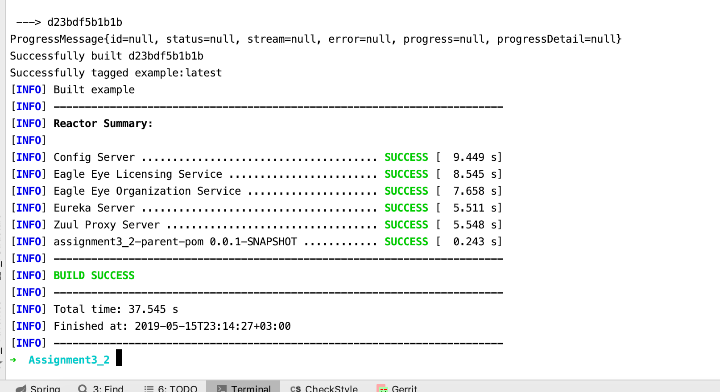

docker-compose -f docker/common/docker-compose.yml up

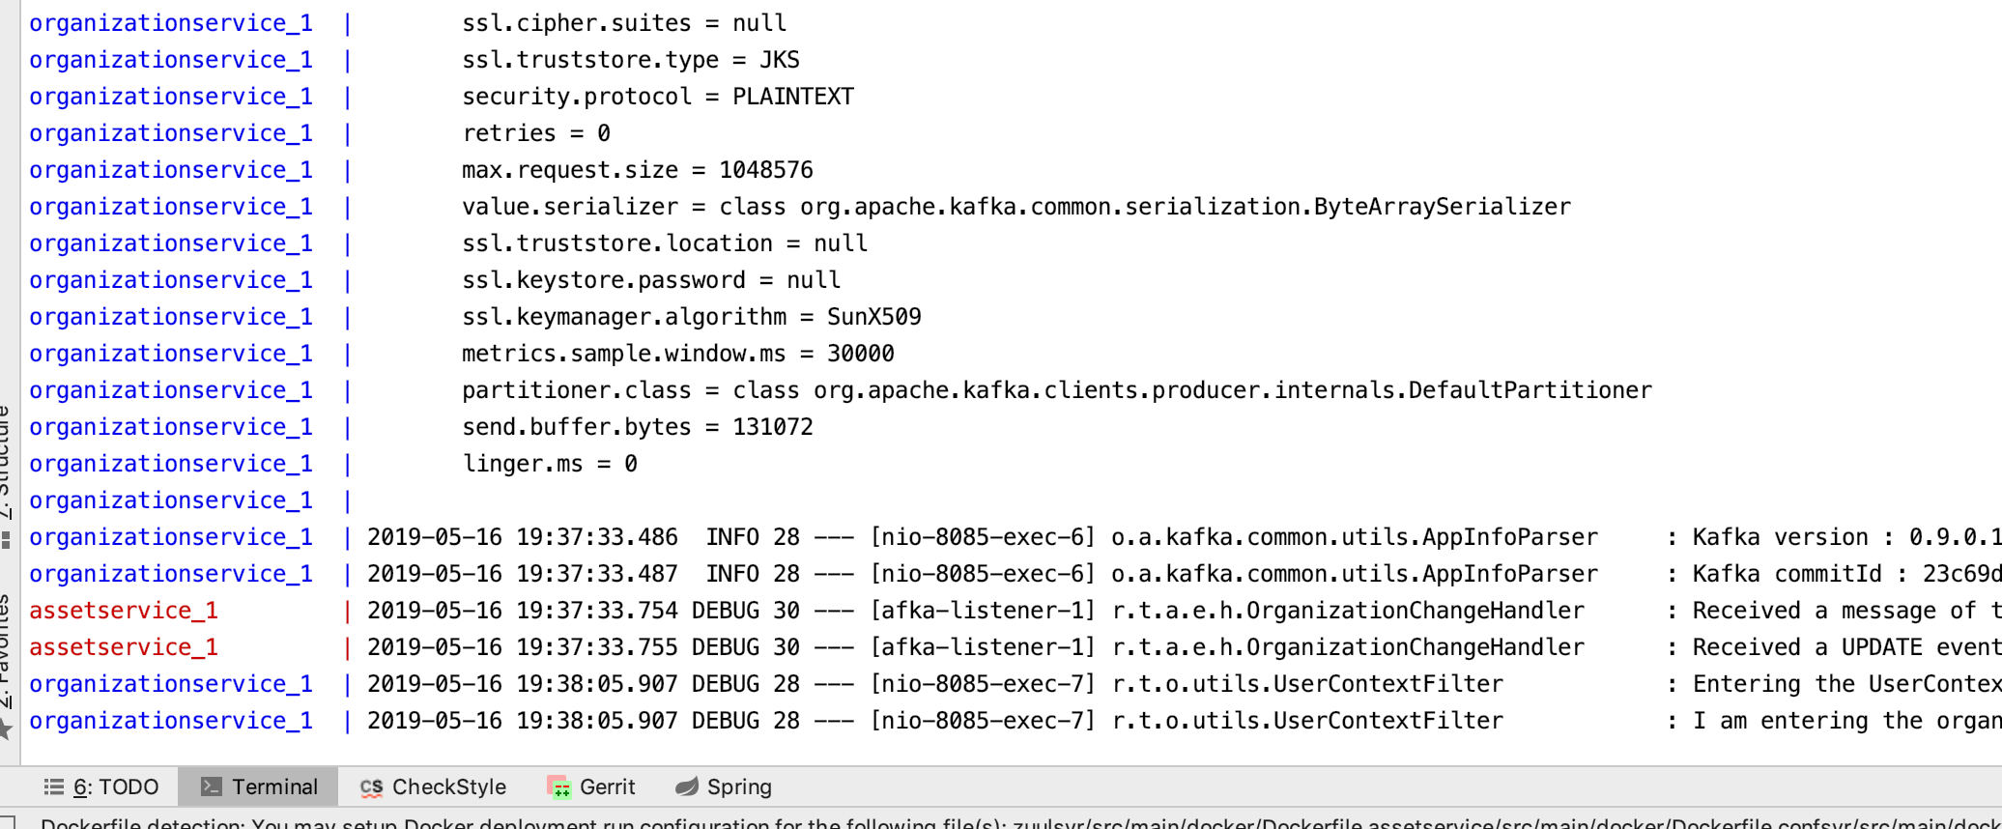

Getting an organization details.

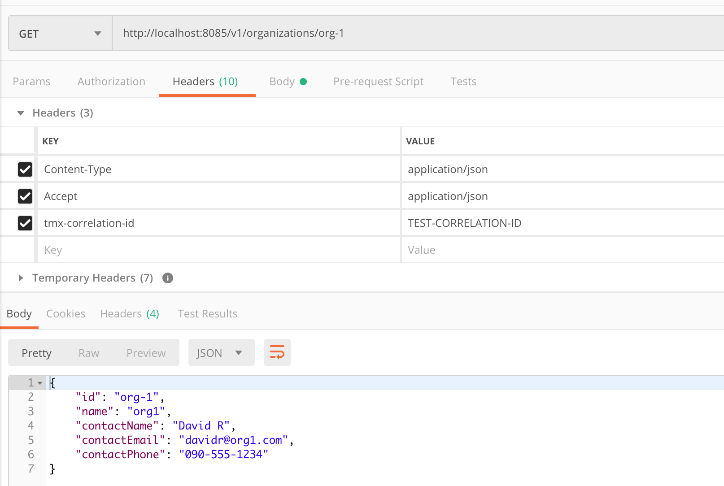

Updating organization details using “Put”

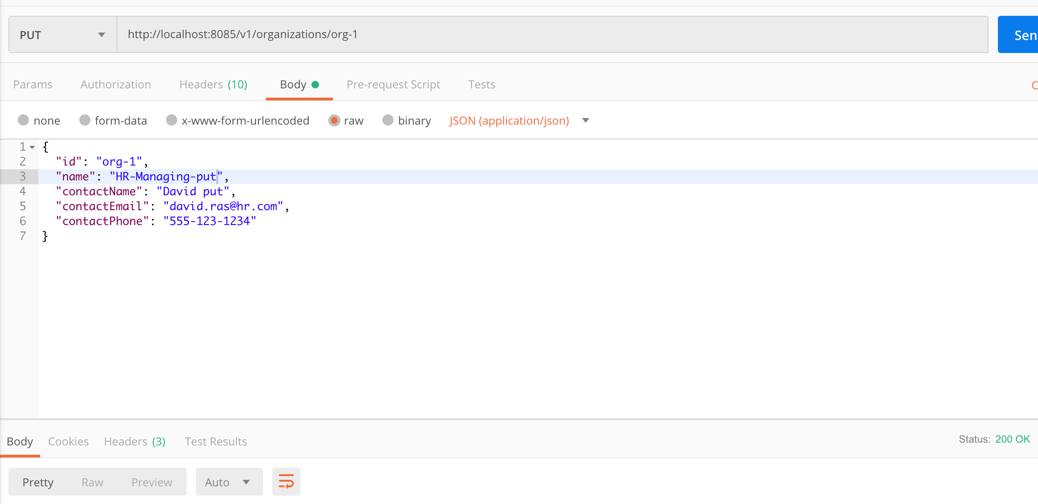

The output shows that we’ve updated the organization entity

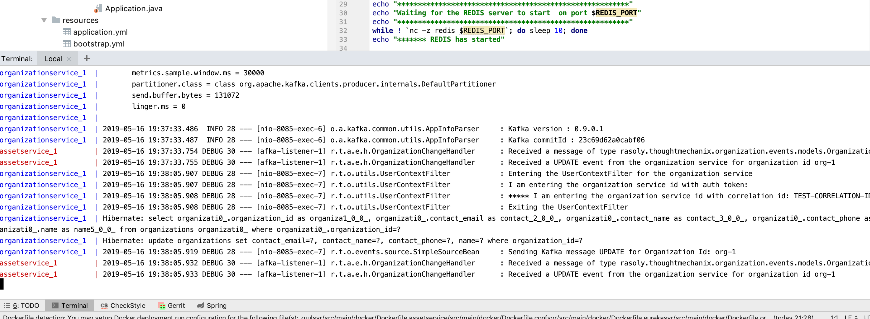

Asserting that both email, name and contact name was changed.

